Setup Android

**Note** – Due to the wide range of Android devices and versions, these screenshots may or may not match your device. However, the steps are the same.

Begin by uninstalling the existing CCV Mobile app if you have it installed.

Visiting Settings

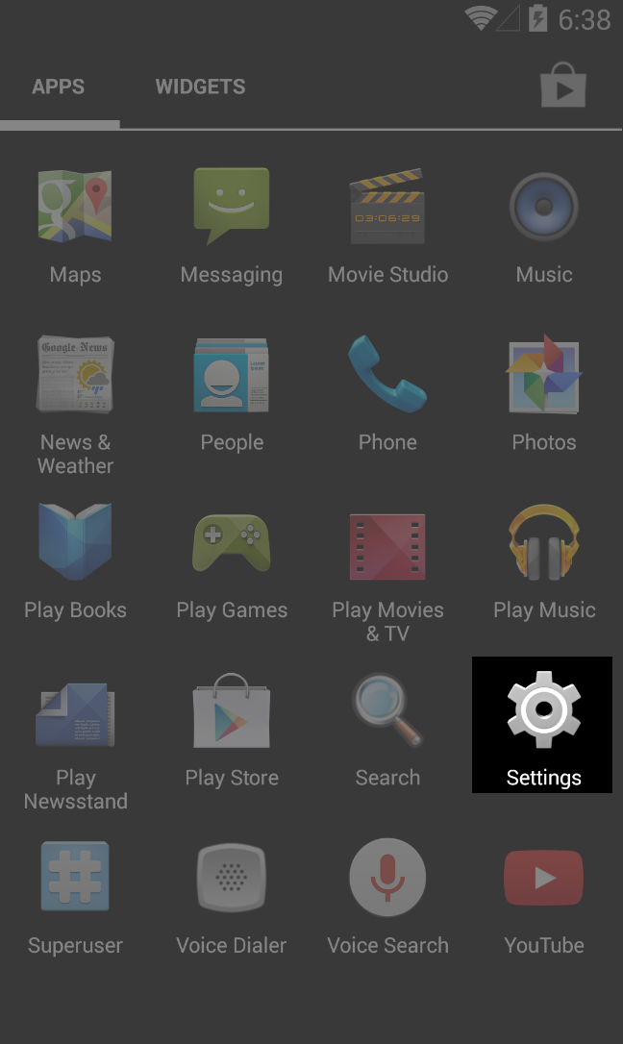

Find Security and select it

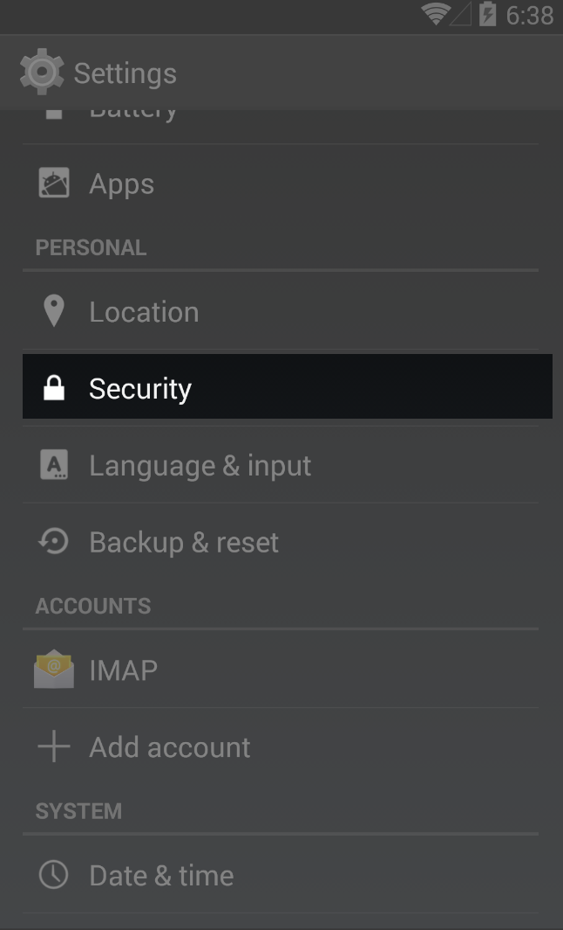

Find “Unknown sources” and tick the check box.

This tells Android you are ok installing apps that are not in the App Store.

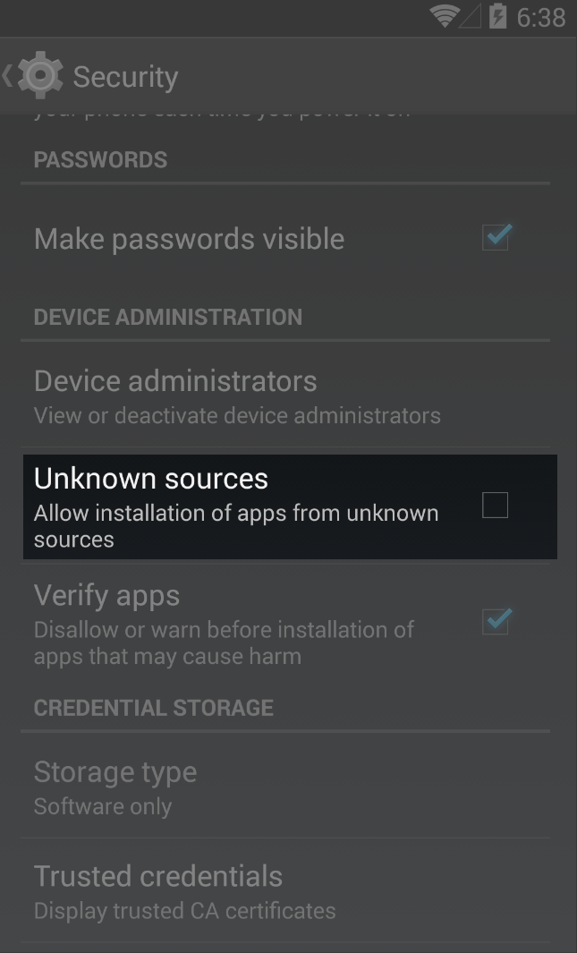

Now open a browser and visit the following address:

<http://www.jeredmcferron.com/app/com.ccvonline.CCVMobileApp-Signed.apk>

If that does not work, visit this address, and tap the second item in the list.

<http://www.jeredmcferron.com/app/>

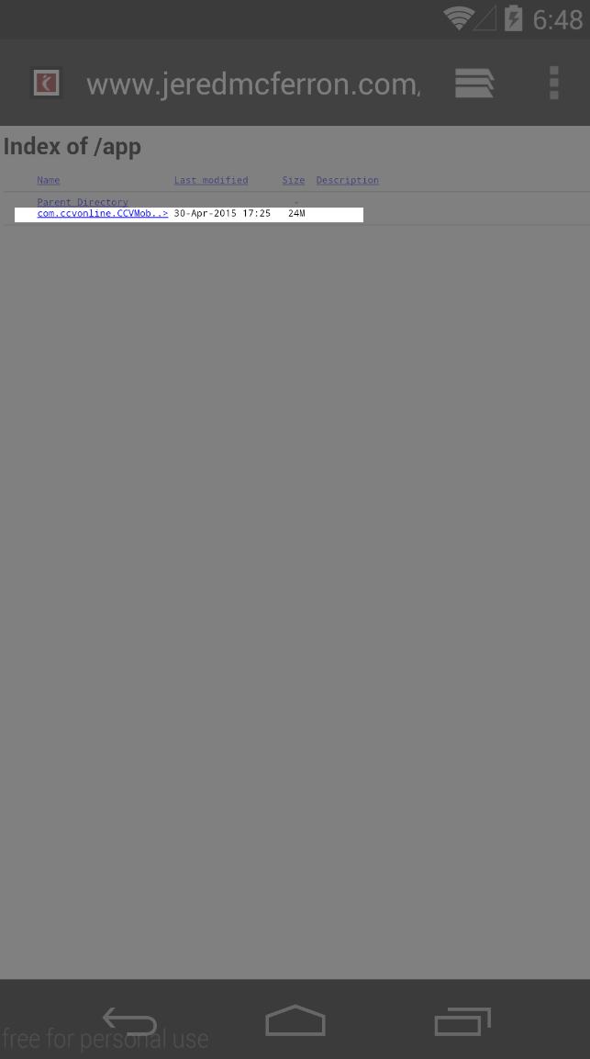

Tap the Downloads Icon

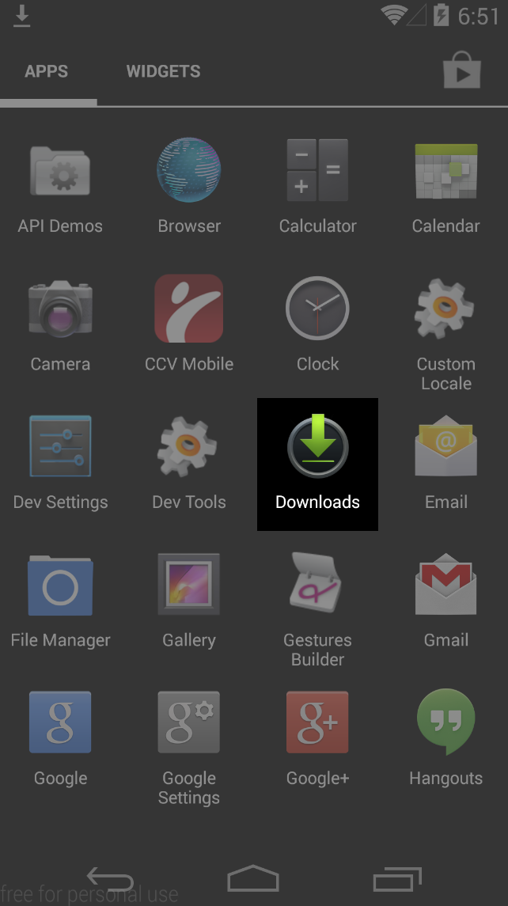

Find and tap the app that was just downloaded. (It might help to sort by date downloaded).

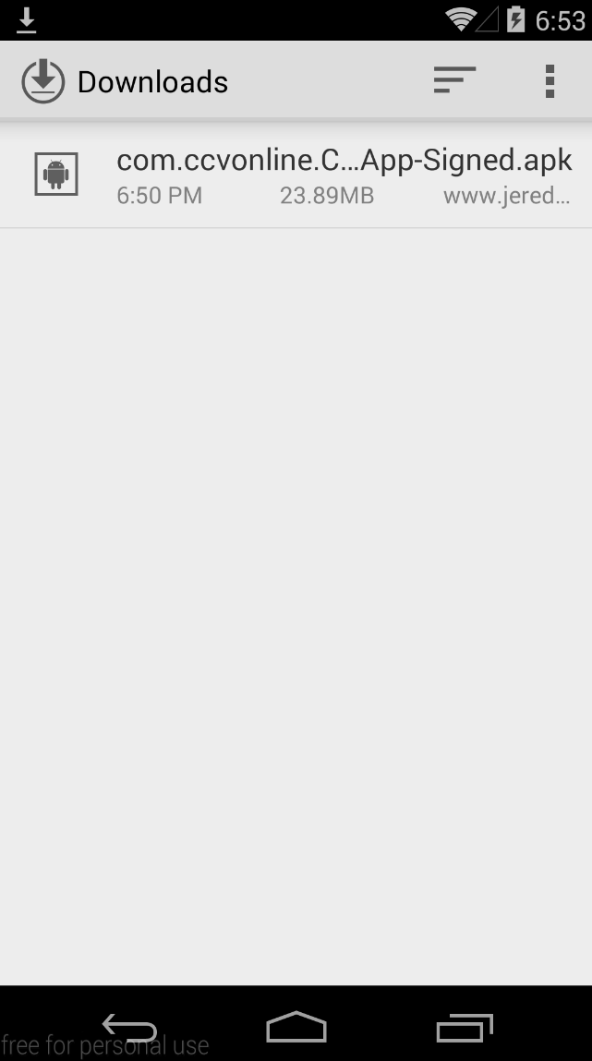

Finally, choose to Install!

